General Comments:
Great paper! The figures are very cool!
- Maybe it would be useful to break it up into sections like Dan’s ME neutrino inclusive paper to support the flow of the paper: https://arxiv.org/pdf/2106.16210

- For writing G_18_02a and G_18_02b on the plots, can perhaps replace it with something like:
G18_02a_02_11a -> GENIE RFG hA
G18_02b_02_11a -> GENIE RFG hN
G18_10a_02_11a -> GENIE LFG hA
G18_10b_02_11a -> GENIE LFG hN
(courtesy of Adrian Lozano)
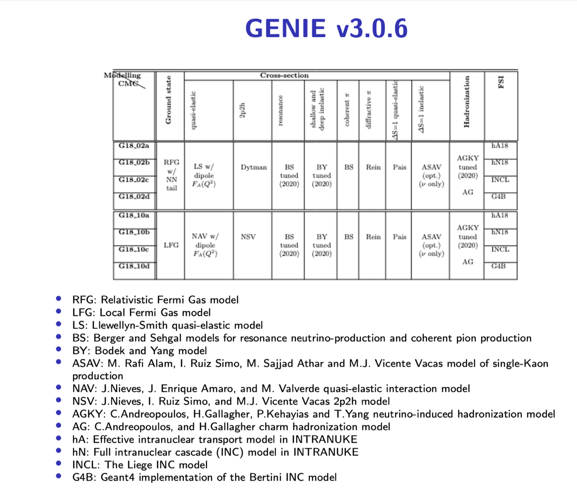
Specific Comments:
L1-2: Perhaps can write that the measurement is as a function of muon pt
L25-27: Maybe could add antineutrino cross-sections on matter are smaller
L100-104: Curious that it doesn’t include the combined flux constraint
FIG. 1: I think it would be nicer to include total lead instead
L245: Perhaps can include citation for this (if already have the citation at hand)
L304-L317: Perhaps can add in a table of the chi2 values for the model comparisons to support the discussion in these lines.
L320 – L324: Curious about what the motivation is for the underprediction not being present as much in lead (between 0.4 and 1 GeV/c)

I really enjoyed the conclusion! I thought it was concise and articulate.

